

**College of Basic and Applied Sciences**

**School of Engineering Sciences**

**Department of Computer Engineering**

**First Semester 2022 Academic Year**

**CPEN 405: Artificial Intelligence**

**Course Project**

**PART 1: Machine Learning**

**GROUP 5**

***10732602 - Sasu Benjamin Yeboah***

***10743593 - Fordjour Jefferson***

***10714326 - Amanfo Oforiwaa Abena***

**INTRODUCTION**

Artificial intelligence is all about equipping machines with human-like intelligence. Artificial intelligence is now in vogue in the technology world. From smart devices through robotics and even to personalized disease diagnosis and drug design. Because of the huge potential benefits, it has received a lot of attention and its growth is sponsored by several entities. PART 1 is mainly about machine learning using WEKA. The project's goal is to gain practical experience with machine learning methods by using software such as WEKA to solve real-world data mining problems, as well as to gain a better understanding of some of the algorithmic issues that arise when designing and applying various machine learning algorithms. For our experiments, we used 10-fold cross validation with 5 classification schemes for Soybean Disease Diagnosis. After which, we used the WEKA Experiment Paired Corrected T-Tester to compare the classification schemes for their performance. The dataset used was Soybean, with its training and test database combined into a single file, from the UCI Machine Learning Repository, and 5 classification schemes were applied to it for evaluation. These data sets were selected because they are large enough to allow moderate size train and validation sets, and still have data left for large final test sets. It proved to be the best fit for the constraints provided in the instructions given.

**PROBLEM FORMULATION**

The following are its characteristics/ the rationale behind the datasets’s selection:

There are 683 Instances, 19 classes (different diseases in soybean plant), however only the first 15 have been utilized previously. Because there are so few cases, the consensus seems to be that the last four classes are invalidated by the evidence. After performing Attribute Selection utilizing Attribute Ranking Search Method on it, there are 36 attributes, but 35 categorical attributes, some nominal and others sorted.

|  |  |  |  |  |  |
| --- | --- | --- | --- | --- | --- |
| Data Set Characteristics | Multivariate | Number of Instances | 683 | Area | Life |
| Attribute Characteristics | Categorical | Number of Attributes | 35 | Date Donated | 1988/07/11 |
| Associated Tasks | Classification | Missing Values? | Yes | No. of Web Hits | 153160 |

**Attribute Information**:

**Classes:** diaporthe-stem-canker, charcoal-rot, rhizoctonia-root-rot,

phytophthora-rot, brown-stem-rot, powdery-mildew, downy-mildew, brown-spot, bacterial-blight, bacterial-pustule, purple-seed-stain, anthracnose, phyllosticta-leaf-spot, alternarialeaf-spot, frog-eye-leaf-spot, diaporthe-pod-&-stem-blight, cyst-nematode, 2-4-d-injury, herbicide-injury.

**Attributes:**

1. date: april, may, june, july, august, september, october,?.

2. plant-stand: normal, lt-normal,?.

3. precip: lt-norm,norm,gt-norm,?.

4. temp: lt-norm, norm, gt-norm,?.

5. hail: yes, no,?.

6. crop-hist: diff-lst-year, same-lst-yr, same-lst-two-yrs,

same-lst-sev-yrs,?.

7. area-damaged: scattered,low-areas,upper-areas,whole-field,?.

8. severity: minor,pot-severe,severe,?.

9. seed-tmt: none,fungicide,other,?.

10. germination: 90-100%,80-89%,lt-80%,?.

11. plant-growth: norm,abnorm,?.

12. leaves: norm,abnorm.

13. leafspots-halo: absent,yellow-halos,no-yellow-halos,?.

14. leafspots-marg: w-s-marg,no-w-s-marg,dna,?.

15. leafspot-size: lt-1/8,gt-1/8,dna,?.

16. leaf-shread: absent,present,?.

17. leaf-malf: absent,present,?.

18. leaf-mild: absent,upper-surf,lower-surf,?.

19. stem: norm,abnorm,?.

20. lodging: yes,no,?.

21. stem-cankers: absent,below-soil,above-soil,above-sec-nde,?.

22. canker-lesion: dna,brown,dk-brown-blk,tan,?.

23. fruiting-bodies: absent,present,?.

24. external decay: absent,firm-and-dry,watery,?.

25. mycelium: absent,present,?.

26. int-discolor: none,brown,black,?.

27. sclerotia: absent,present,?.

28. fruit-pods: norm,diseased,few-present,dna,?.

29. fruit spots: absent,colored,brown-w/blk-specks,distort,dna,?.

30. seed: norm,abnorm,?.

31. mold-growth: absent,present,?.

32. seed-discolor: absent,present,?.

33. seed-size: norm,lt-norm,?.

34. shriveling: absent,present,?.

35. roots: norm,rotted,galls-cysts,?.

**SOLUTION APPROACH AND ALGORITHMS**

We used 10-fold cross validation with 5 classification schemes for Soybean Disease Diagnosis. After which, we used the WEKA Experiment Paired Corrected T-Tester to compare 3 classification schemes for their performance. The raw data was pre-processed in various ways. Firstly, the ordinal inputs were normalized to have zero mean and unit standard deviation on the training data. Part of the inputs are categorical and these are mapped to a 1-of-c coding, thus increasing the number of attributes from 35 to 36. The worth of "dna" stands for "does not apply." The values for characteristics are encoded numerically, with "0" being the first value, "1" being the second, and so on. The value of an unknown value is encoded as "?" for each of the five algorithms.

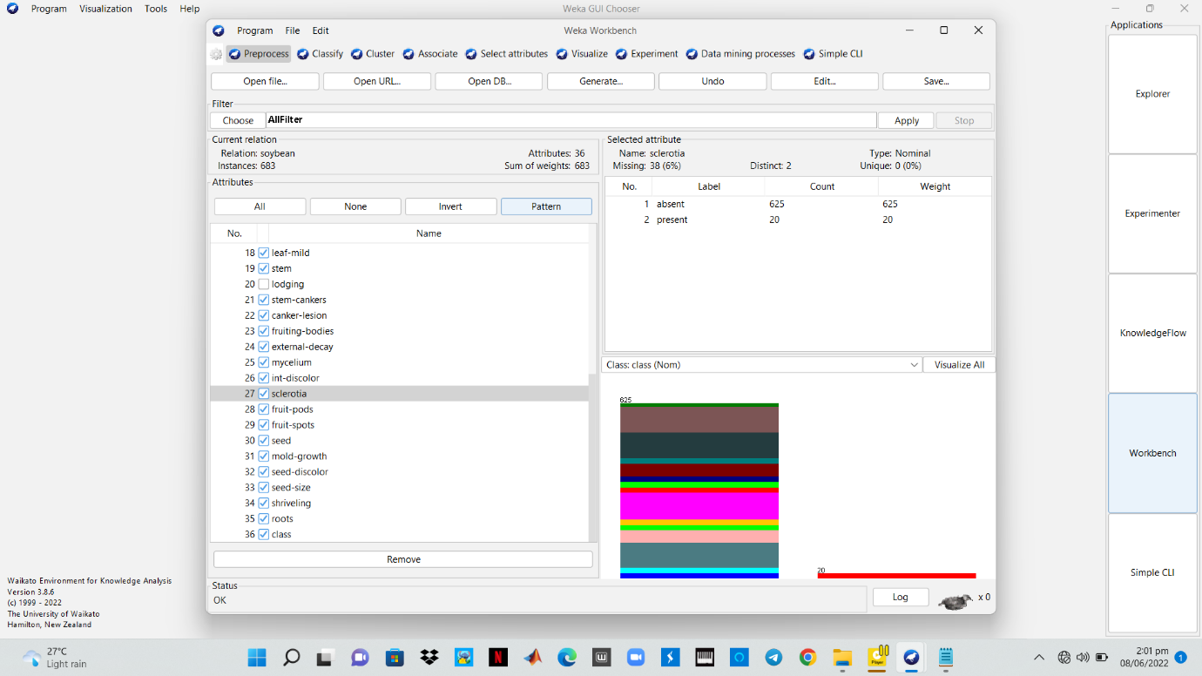

**Data Preprocessing**

env( precipitation) = [l,n]

The following results were obtained (using the ranked rules and [prop] strategy):

% identification = 50

Indecision Ratio = 1.9

The data was modified so that:

env( precipitation) = g

env( precipitation) = n

and the rule condition used was:

env( precipitation) = [g,n]

The results obtained (using the same rules and strategy) were:

% identification = 50

Indecision Ratio = 2.3

Specificity Index = 7.5

The changes in the Indecision Ratio were due to three extra false positive identifications of cases of phyllosticta leaf spot as brown spot and one false positive identification of phyllosticta leaf spot as frog eye leaf spot. The changes in the Specificity Index were due to eight cases of brown spot, and three cases of alternaria leaf spot being incorrectly identified as phyllosticta leaf spot.

***ALGORITHMS***

**Naive Bayes** classifiers are a family of simple "probabilistic classifiers" based on applying Bayes' theorem with strong independence assumptions between the features. They are among the simplest Bayesian network models, but coupled with kernel density estimation, they can achieve high accuracy levels.

**Bagging**, also known as bootstrap aggregation or Random Forest, is the ensemble learning method that is commonly used to reduce variance within a noisy dataset. In bagging, a random sample of data in a training set is selected with replacement meaning that the individual data points can be chosen more than once.

**K-means clustering algorithm** computes the centroids and iterates until it finds optimal centroid. It assumes that the number of clusters are already known. It is also called flat clustering algorithm. The number of clusters identified from data by algorithm is represented by 'K' in K-means.

**Random forest** is a Supervised Machine Learning Algorithm that is used widely in Classification and Regression problems. It builds decision trees on different samples and takes their majority vote for classification and average in case of regression.

**Stacked Generalization**, or stacking for short, is an ensemble machine learning algorithm. Stacking involves using a machine learning model to learn how to best combine the predictions from contributing ensemble members.

**RESULTS AND DISCUSSION**

***Ranked Attributes:***

**Evaluator: weka.attributeSelection.InfoGainAttributeEval**

**Search: weka.attributeSelection.Ranker -T -1.7976931348623157E308 -N -1**

**Relation: soybean, Instances: 683, Attributes: 36**

**Evaluation mode: Evaluate on all training data**

**=== Attribute Selection on all input data ===**

**Search Method: Attribute ranking.**

**Attribute Evaluator (supervised, Class (nominal): 36 class): Information Gain Ranking Filter**

**Ranked attributes:**

1.1517 22 canker-lesion

1.0129 15 leafspot-size

0.9852 29 fruit-spots

0.8684 13 leafspots-halo

0.8535 21 stem-cankers

0.8504 14 leafspots-marg

0.8437 28 fruit-pods

0.6918 19 stem

0.6715 1 date

0.6265 11 plant-growth

0.5853 3 precip

0.5392 35 roots

0.5245 26 int-discolor

0.4829 24 external-decay

0.4808 7 area-damaged

0.4241 4 temp

0.4133 30 seed

0.3614 18 leaf-mild

0.3568 12 leaves

0.3517 23 fruiting-bodies

0.3432 31 mold-growth

0.3106 8 severity

0.2981 33 seed-size

0.2862 2 plant-stand

0.2688 32 seed-discolor

0.2629 16 leaf-shread

0.2465 17 leaf-malf

0.2173 34 shriveling

0.1883 27 sclerotia

0.0987 20 lodging

0.0787 6 crop-hist

0.0784 5 hail

0.0742 9 seed-tmt

0.0554 10 germination

0.0461 25 mycelium

**Selected attributes:** 22,15,29,13,21,14,28,19,1,11,3,35,26,24,7,4,30,18,12,23,31,8,33,2,32,16,17,34,27,20,6,5,9,10,25 : 35

***Ranked Attributes 2(Best First):***

**Evaluator: weka.attributeSelection.CfsSubsetEval -P 1 -E 1**

**Search: weka.attributeSelection.BestFirst -D 1 -N 5**

**Relation: soybean, Instances: 683, Attributes: 36**

***Evaluation mode: evaluate on all training data***

***=== Attribute Selection on all input data ===***

**Search Method:** Best first.

**Start set:** no attributes

**Search direction:** forward

**Stale search after 5 node expansions**

**Total number of subsets evaluated:** 552

**Merit of best subset found: 0.702**

**Attribute Subset Evaluator (supervised, Class (nominal): 36 class): CFS Subset Evaluator, Including locally predictive attributes**

**Selected attributes:** 1,3,4,5,7,8,9,10,11,12,13,15,17,18,19,22,23,24,26,28,30,35 : 22

* + - **date**
    - **precip**
    - **temp**
    - **hail**
    - **area-damaged**
    - **severity**
    - **seed-tmt**
    - **germination**
    - **plant-growth**
    - **leaves**
    - **leafspots-halo**
    - **leafspot-size**
    - **leaf-malf**
    - **leaf-mild**
    - **stem**
    - **canker-lesion**
    - **fruiting-bodies**
    - **external-decay**
    - **int-discolor**
    - **fruit-pods**
    - **seed**
    - **roots**

**CLASSIFICATION RESULTS**

Double Click to view a detailed report of results. This includes: Scheme, Test mode, Classifier model, Predictions on training set, Time taken to build model, Actual prediction, Error prediction, Summary on Correctly Classified Instances, Incorrectly Classified Instances, Kappa statistic, Mean absolute error, Root mean squared error, Relative absolute error, Root relative squared error, and Detailed Accuracy By Class(TP Rate, FP Rate, Precision, Recall, F-Measure, MCC, ROC Area, PRC Area, and Weighted Avg.), as well as the Confusion Matrix.

**Naive Bayes:**



**Bagging:**



**K-means:**



**Random forest:**



**Stacked Generalization:**



**Plots Of Arrtributes:**

Below is the visualization of all the attributes

